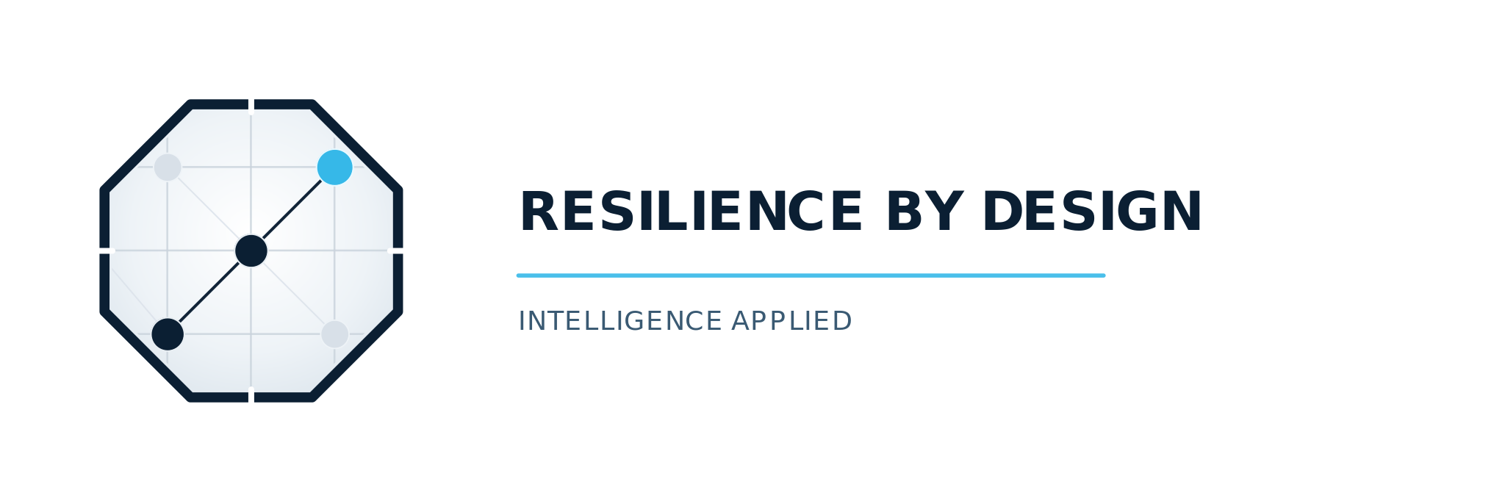 | INTELLIGENCE APPLIED

YOUR ORGANIZATION HAS INVESTED IN SECURITY.
The harder question is whether you can recover when security fails.
Most organizations are not prepared to restore critical services after a severe cyber outage — one where primary systems, backups, and conventional recovery tools fail simultaneously. The gap between what boards believe and what organizations can actually demonstrate is where the greatest risk hides.
WHY MOST PLANS FAIL  Traditional Business Continuity Plans are built around applications and assets, not business outcomes. When a severe outage hits every system at once, application-centric plans have no answer for immediate survival.  The result: systems restored in priority order while customers wait, regulators ask questions no one can answer, and boards discover the plan they approved doesn't work for the attack that actually happened. | A DIFFERENT APPROACH  We start with one question: what is the minimum your organization must deliver to remain viable? Dependency mapping, restoration protocols, tested recovery velocity, and Board-level accountability follow from that answer.  AI-assisted tools make this faster and more accurate than ever and keep your plan current as your environment changes.  Resilience by Design builds on the framework the U.S. financial sector chose for severe-outage recovery — Sheltered Harbor, now managed by FS-ISAC.

WHAT WE DO
◈ Cyber Recovery Readiness Assessment  A facilitated workshop for your board and C-suite that validates actual recovery readiness and produces a prioritized roadmap. | ◈ Board & Executive Advisory  Strategic resilience advisory — helping boards understand their exposure, mandate the right investments, and hold leadership accountable.
◈ Dependency Management  AI tools translate your minimum viable operation into a continuously maintained map of risks, dependencies, and recovery priorities. | ◈ Recovery Plan Implementation  Prepare and procure an isolated recovery platform, validate that it works through defined testing, and build organizational readiness through ongoing drills.
◈ Cyber Resilience Education  Leadership and operator education that builds the organizational capability to execute recovery under real-world pressure. | ◈ Resilience Management as a Service  Ongoing independent oversight, AI-assisted plan currency, and validated Board reporting — so your posture keeps pace with your environment.

DISCOVER YOUR RESILIENCE SCORE  Take the free Cyber Recovery Readiness Assessment — 10 questions, 8 minutes. Reveals where your organization stands across five dimensions of recovery readiness.  Know your score before a regulator, a board member, or an attacker finds out for you. | START FREE  Resilience-byDesign.com  Takes 8 minutes. No registration required.

